 | Commonwealth of Massachusetts  City/Town of Middlefield  Application for Disposal System Construction Permit  Form 1A |  |  | Number  $  Fee
 | DEP has provided this form for use by local Boards of Health if they choose to do so. Before using the form, check with your local Board of Health to make sure that they will accept it.
 | A. Facility Information
Important: When filling out forms on the computer, use only the tab key to move your cursor - do not use the return key.  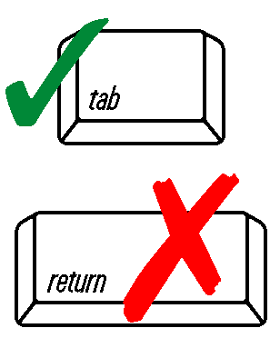 | Application is hereby made for a permit to: Construct a new on-site sewage disposal system  Repair or replace an existing on-site sewage disposal system  Repair or replace an existing system component
 | 1. Location of Facility:
 | Address or Lot #
 | City/Town |  | State |  |  | Zip Code
 | 2. Owner Information
Name

e-mail address (optional)

Address (if different from above)

State

 | City/Town |  | State |  |  | Zip Code
 |  |  | Telephone Number
 | 3. Installer Information
 | Name |  | Name of Company
Address

State

 | City/Town |  | State |  |  | Zip Code
 |  |  | Telephone Number
 | 4. Designer Information
 | Name |  | Name of Company
Address

State

 | City/Town |  | State |  |  | Zip Code
 |  |  | Telephone Number
 | A. Facility Information (continued)
 | 5. Type of Building:
 | Dwelling |  | Garbage Grinder (check if present)
 | Other: Type of Building |  |  |  | Number of Persons Served
 | Showers | Number of showers | Cafeteria |  | Other fixtures
 | Specify other fixtures:
 | 6. Design Flow: |  | Gallons per Day
 | Calculated Daily Flow: |  | Gallons
 | 7. Plan: |  | Date of Original
 | Number of Sheets |  | Revision Date
 | Title of Plan
 | 8. Description of Soil:
 | 9. Nature of Repairs or Alterations (if applicable):
 | 10. Date last inspected: |  | Date
 | B. Agreement
 | The undersigned agrees to ensure the construction and maintenance of the aforedescribed on-site sewage disposal system in accordance with the provisions of Title 5 of the Environmental Code and not to place the system in operation until a Certificate of Compliance has been issued by this Board of Health.
 | Signature |  | Date
 | Application Approved By:
 | Name |  | Date
 | Application Disapproved for the following reasons:

