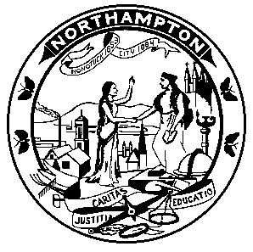 | CITY of NORTHAMPTON  Department of Health and Human Services  Merridith O’Leary, RS ~ Commissioner  Municipal Building ~ 212 Main Street ~ Northampton, MA 01060  Phone (413) 587-1214 ~ Fax (413) 587-1221  http://www.northamptonma.gov/245/Health | 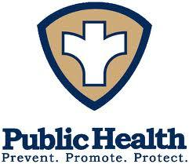

Public Health Nurse Memorandum
April 2026

To: Northampton Based Recreational Camps for Children

From: Northampton Health and Human Services, Public Health Nurses

RE: Medical Policies, Personnel and Records 2026 Recreation Camp Season

Recreational Camp Operators -

Hello, from the Northampton Public Health Nurses, Em Rhodes Moulton and Jennifer Denkiewicz. We are writing to introduce ourselves and offer support and guidance while you ready your Camps Binder for the 2026 Season. It is our role as the Public Health Nurses to collaborate with Inspection ensuring the Camps meet the standards of 105 CMR 430:000: Minimum Standards for Recreational Camps for Children.

The Public Health Nurses focus on thoroughly reviewing the Camp Binder medical policies prior to opening. We ask that each section be clearly labeled.

To ensure a successful review, it is critical that your binder includes the required documents listed below. Samples of these documents are available on our webpage for your reference. northamptonma.gov/2505/Recreactional-Camps

- Health Care Consultant Agreement Sample
- Written Orders for Medication Administration Sample
- Written Standing Orders Sample
- Camp Training Samples
- Competency Checklist Sample
- Medication List Sample
- First Aid Kits A/B
- Infection Control Plan Sample
- Immunizations for K-12, 18 Years and Older

Public Health Nursing, also performs an onsite inspection where we inspect:
- Designated infirmary
- Class A and Class B First Aid Kits fully stocked
- Locked cabinet for storing medications
- Locked fridge for medications with thermometer
- Medical Waste management i.e. sharps containers
- Immunization and physical records for all campers and staff, see attached Measles Outbreak Memo

We look forward to working with you,
Em Rhodes Moulton, Jennifer Denkiewicz, Northampton Public Health Nurses

